Weighted Analyses Example Solution
The true population mean of the percentage of students tested is estimated as 98.45 (SE = 0.22), using weighting. This is not substantially different from the unweighted mean of 98.11 (SE = 0.27), and indeed not significantly different as the 95% confidence intervals would overlap. Similarly, the weighted mean of the percentage of fully qualified teachers is 86.88 (SE = 1.10), which is not significantly different from the unweighted mean of 86.6 (SE = 0.96). There is a notable difference between the weighted estimate of the population proportion of schools eligible for awards (0.64, SE = 0.038) and the unweighted proportion (0.565, SE = 0.035).
Visualising the weighted and unweighted distributions of these variables, for percentage of fully qualified teachers (Figure 1), we see similarities between the weighted and unweighted distributions, with the unweighted having slightly more in the 80-90% range.
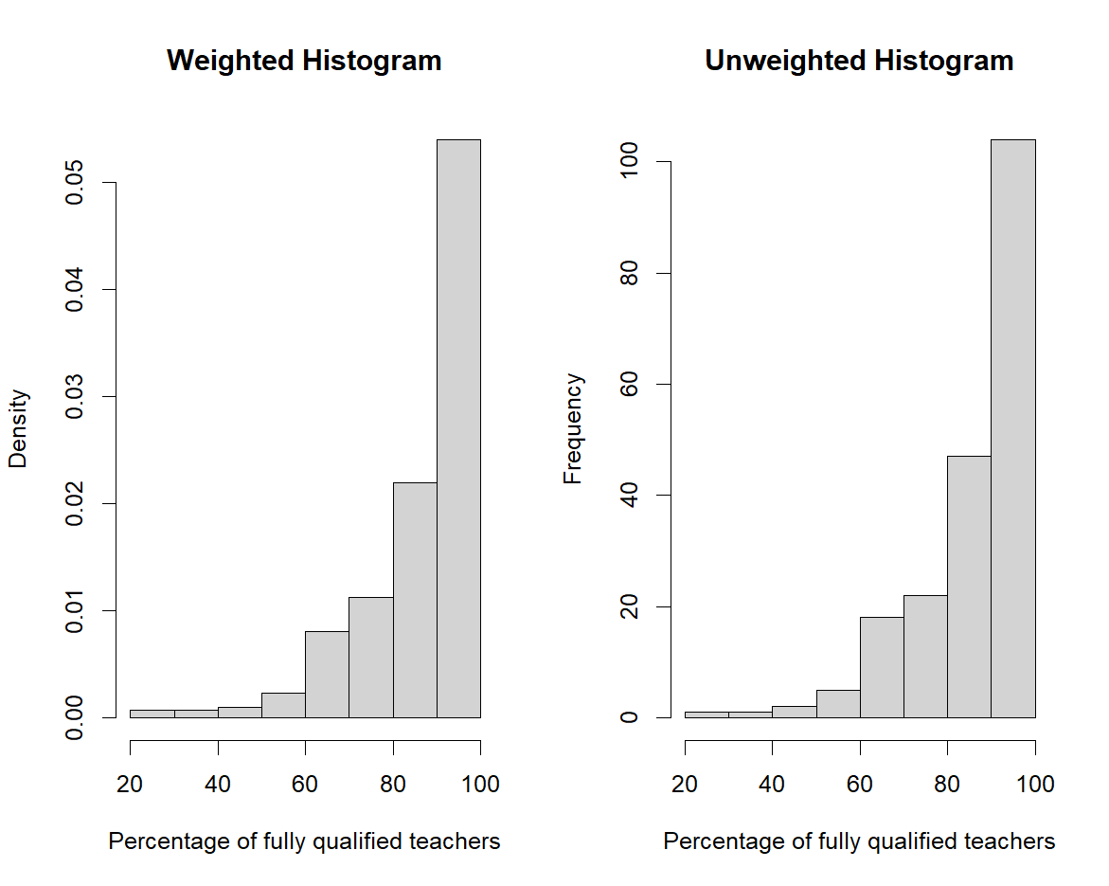
Figure 1: Comparison of weighted and unweighted histograms of the distribution of the percentage of fully qualified teachers.
The percentages of student fully tested are extremely high such that there is no noticeable difference between the weighted and unweighted distributions (Figure 2).
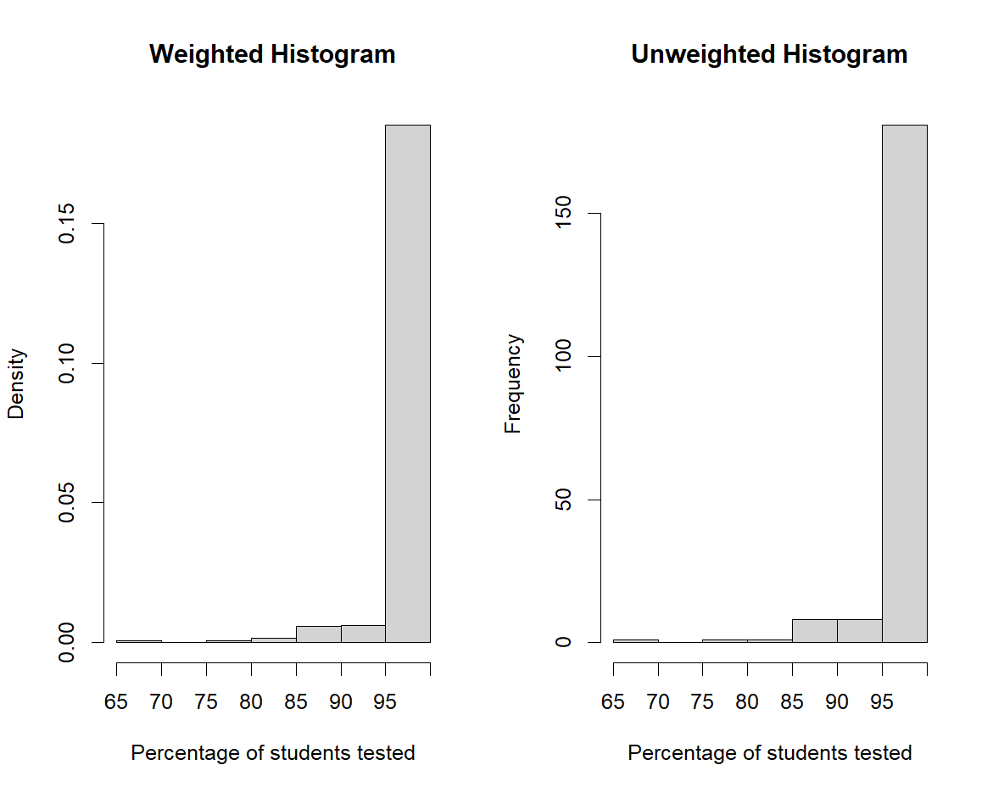
Figure 2: Comparison of weighted and unweighted histograms of the distribution of the percentage of students tested.
Considering the plot of students enrolled vs students tested (Figure 3), we see that there is a no notable association between students on free school meals and students tested. More weight has been given to schools with fewer students tested, which given the above percentages of students tested, would also have been smaller schools, as evidenced by the bolder dots on the scatterplot.
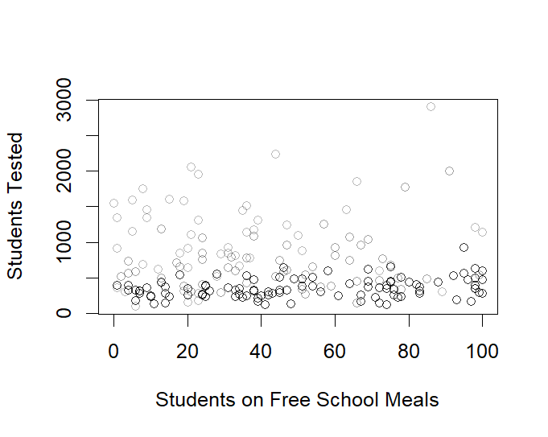
Figure 3: Weighted scatterplot comparing students on free school meals and students tested for API.

Considering the weighted regression of variables that may affect the percentage of fully qualified teachers (Table 1), we see a significant negative effect of the number of students on free school meals (p<0.001), the percentage of students for whom it is their first year at the school (p=0.04), and the average parental education level (p=0.043). The former two may possibly be due to socioeconomic factors, with schools in poorer areas more likely to need to take unqualified teachers than those in more affluent areas.
This contrasts to the unweighted analysis, which only finds a significant effect of the percentage of students on free school meals (p<0.001). This demonstrates the necessity of weighting survey analyses as likely population trends may be masked in unweighted analyses.

Variable | Estimate | Standard Error | P Value
Eligible for Awards | 2.80 | 3.43 | 0.416
% on free school meals | -0.37 | 0.09 | <0.001
Average K-3 class size | 0.60 | 0.75 | 0.427
Average 4-6 class size | -0.22 | 0.30 | 0.462
% students in first year | -0.15 | 0.07 | 0.040
Parental education | -5.69 | 2.78 | 0.043
Table 1: Results from the weighted regression model

Variable | Estimate | Standard Error | P Value
Eligible for Awards | 2.80 | 2.96 | 0.348
% on free school meals | -0.37 | 0.08 | <0.001
Average K-3 class size | 0.60 | 1.11 | 0.591
Average 4-6 class size | -0.22 | 0.42 | 0.600
% students in first year | -0.15 | 0.12 | 0.211
Parental education | -5.69 | 3.46 | 0.103
Table 2: Results from the unweighted regression model

Sample R Code
library(survey)
data("api")

apistrat_design <- svydesign(data = apistrat,
weights = ~pw,
fpc = ~fpc,
id = ~1,
strata = ~stype)
summary(apistrat_design)

svymean(~pcttest, apistrat_design)
mean(apistrat$pcttest)
sd(apistrat$pcttest)/sqrt(200)

svymean(~full, apistrat_design)
mean(apistrat$full)
sd(apistrat$full)/sqrt(200)

svyciprop(~awards, apistrat_design)
table(apistrat$awards)
p=113/200
sep=sqrt((p*(1-p))/200)
p+1.96*sep

# visualise

par(mfrow=c(1,2))

svyhist(~pcttest, apistrat_design, xlab="Percentage of students tested", main="Weighted Histogram")
hist(apistrat$pcttest, xlab="Percentage of students tested", main = "Unweighted Histogram")

svyhist(~full, apistrat_design, xlab="Percentage of fully qualified teachers", main="Weighted Histogram")
hist(apistrat$full, xlab="Percentage of fully qualified teachers", main = "Unweighted Histogram")

par(mfrow=c(1,1))
svyplot(api.stu~meals, apistrat_design, xlab="Students on Free School Meals" ,ylab="Students Tested", style="transparent", legend-TRUE)

#regression

lmw=svyglm(full~awards+meals+acs.k3+acs.46+mobility+avg.ed, design=apistrat_design)
summary(lmw)

lmuw=lm(full~awards+meals+acs.k3+acs.46+mobility+avg.ed, data=apistrat)
summary(lmuw)

